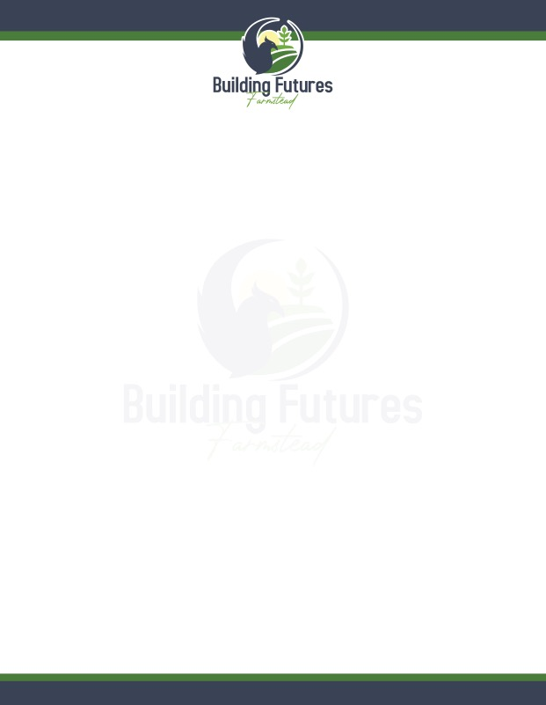Dear Friend,
Thank you for supporting the mission of Building Futures Farmstead. Your generous contribution helps us to create opportunities for adults with autism to develop life skills, engage in meaningful work, and build social connections through farming and nature-based activities.

Please complete the form below and mail it along with your donation to the address listed below.

Donor Information

Name:
Address:

Phone:
Email:

Donation Amount: ☐ $25 ☐ $50 ☐ $100 ☐ $250 ☐ Other: $

Payment Method:

☐ Check (Payable to Building Futures Farmstead)

Would you like to receive updates from us?

☐ Yes, please add me to your mailing list
☐ No, thank you

Your donation is tax-deductible to the extent allowed by law. Building Futures Farmstead is a 501(c)(3) nonprofit organization. Once we receive your donation, we will send a receipt for your records to your home and email address.

Thank you for your generosity!

Warm regards,

Katie Ford
President/Founder
PO Box 67, Belton, SC 29627
katie@buildingfuturesfarmstead.org
(864)210-8399

